

news values

By Atchaya Priya G



## News Values Included:

**Impact**  
This story has a **high impact**, as it discusses the potential causes of a **major aircraft crash** (Air India Flight AI 171). It affects not only the **aviation industry**, but also **public confidence in air safety** and regulatory mechanisms. The mention of Boeing 787-8 and FAA advisories implies a **global impact** beyond India.

**Timeliness**

The issue is current, with reference to recent actions like:

• The FAA’s Continued Airworthiness Notification on July 11

• Ongoing investigations by the AAIB

This gives the story relevance in the present moment.

**Prominence**

The article involves **prominent institutions**:  
**• Air India**  
**• FAA (US Federal Aviation Administration)**  
**• Boeing**

**• AAIB (Aircraft Accident Investigation Bureau)**

These increase the newsworthiness due to their authority and recognition.

**Novelty**

The focus on electrical/software faults and the fuel switch lock issue adds a novel angle to a traditional air crash story, especially as previous potential causes are ruled out.

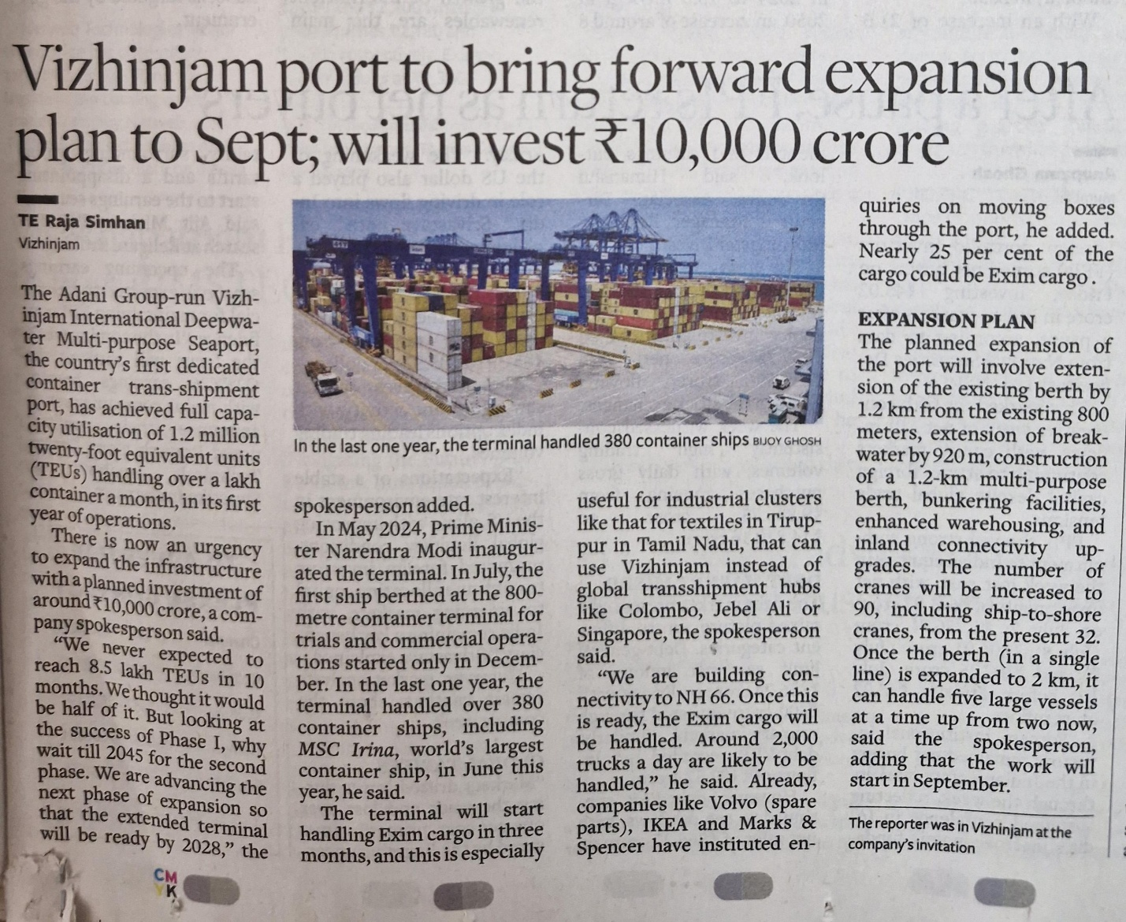

## News Values Included:

**Impact**

The expansion of Vizhinjam port and a ₹10,000 crore investment will significantly affect trade, logistics, and infrastructure development in India.

**Timeliness**

The news is relevant because the expansion work will start as early as September and is planned earlier than expected.

**Prominence**

The involvement of Prime Minister Narendra Modi, a high-profile leader, adds prominence to the story.

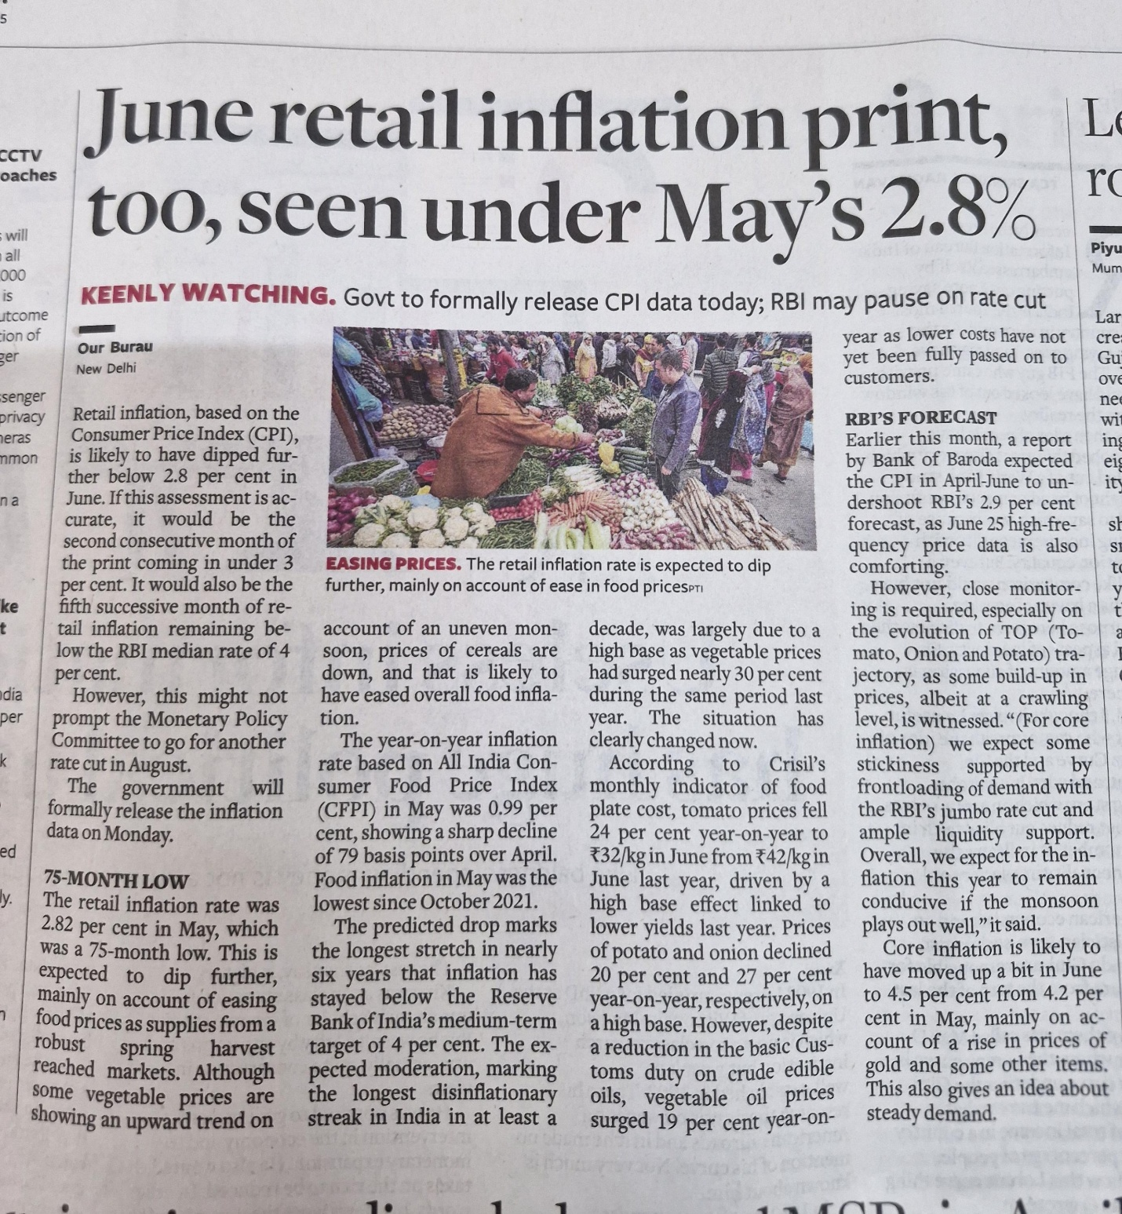

## News Value included:

**Timeliness**  
• The article talks about June inflation data that is expected to be released **soon (formally on Monday)**. It is **current and relevant**, as inflation impacts daily life and economic policy decisions.

**Impact**

• The fall in inflation affects **millions of consumers**, especially in terms of **food prices**, which is a daily necessity. The article explains how this dip could influence **RBI’s decision on interest rates**, affecting loans, savings, and the broader economy.

**Proximity (Economic Relevance to Indian Public)**  
• The news is highly relevant to the **Indian audience**, focusing on Indian CPI, RBI, food price trends, and monsoon impact.

**Conflict**

• There’s a conflict in expectations: while inflation is easing, the RBI may still pause rate cuts due to incomplete transmission of benefits to customers, showing policy tension.

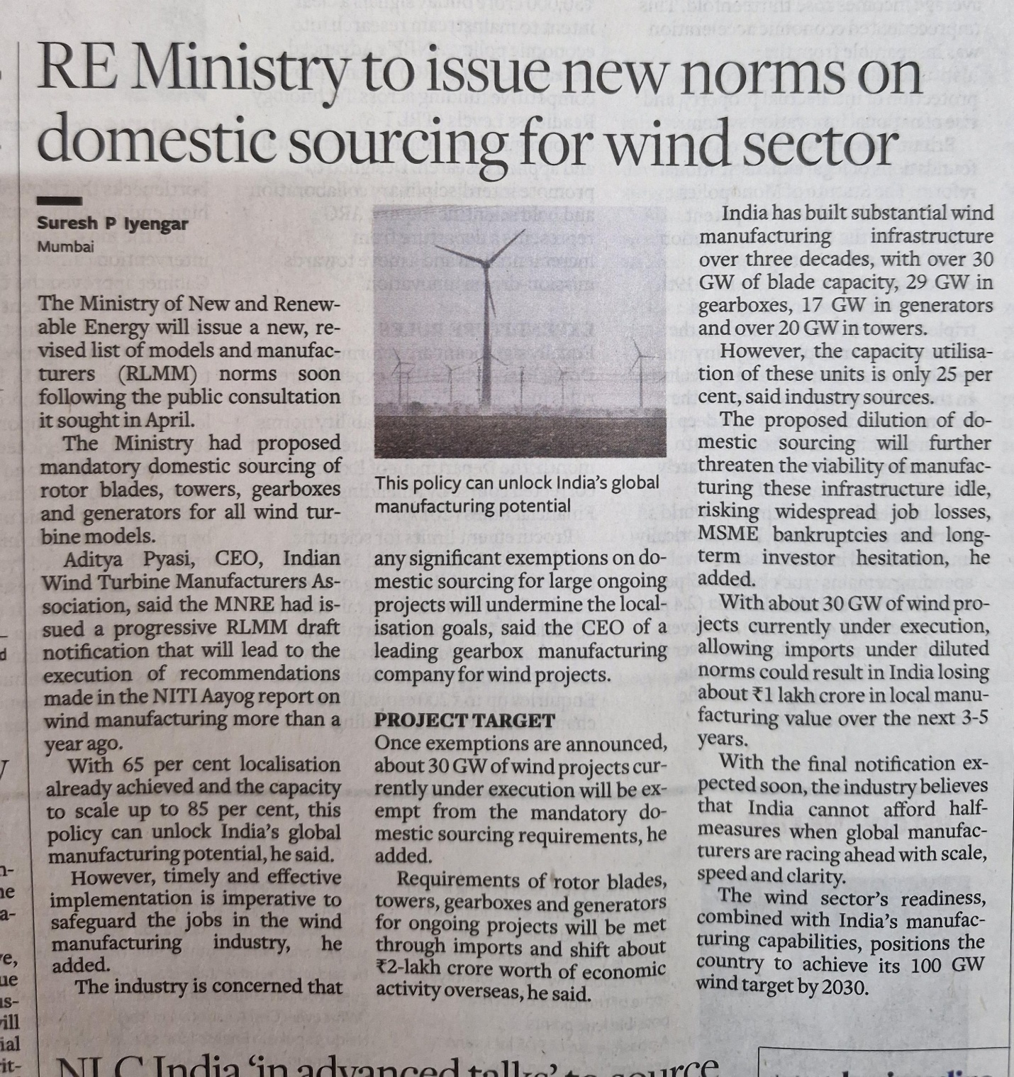

## News Values Included:

**Timeliness**

• The news is current, discussing an upcoming revised RLMM (Revised List of Models and Manufacturers) notification.

**Proximity**

• The issue is national, directly affecting India’s renewable energy policy, domestic manufacturers, and the economic landscape.

**Novelty**

Talks about India’s ambition to achieve 100 GW of wind energy by 2030, and the effort to push 85% localization, which represents new and forward-looking developments.

## News Values Included:

**Conflict**  
The primary news value here is conflict, as the story highlights ongoing diplomatic tensions between India and China over the issue of Tibet and the Dalai Lama’s reincarnation.

**Timeliness**  
The news is timely as it comes ahead of External Affairs Minister S. Jaishankar’s visit to China for the SCO meeting on July 14 and 15, making it relevant and current.

**Proximity**  
The story is significant to Indian readers due to its direct impact on India-China relations, involving Indian leadership and diplomatic interests.